Database Development for a Mobile application to Collect Dysmenorrhea Data
- System intent
This project is centered on the development of a database for a mobile application focused on collecting and managing the data for the pathology dysmenorrhea. The system is aimed to register and store the user’s symptoms, menstrual cycle information and the biomarkers, for a future data analysis or integration of artificial intelligence. The database for dysmenorrhea is built from a previous Android application, in order to extend it by utilizing a structured and scalable database. The work consists in transforming the application requirements into a conceptual data model, Entity-Relationship (ER) diagram, and converting this into a relational schema which is implemented by using SQL

- Project features
1. User registration and identification
The system allows each user to be identified and associated with their records.
2. Storage of personal and clinical background information
The system stores demographic and gynecological information such as age, weight, height, infertility, family history, age at menarche, and nulliparity.
3. Record menstrual cycles
The system allows each user to register multiple menstrual cycles.
4. Track daily symptoms
The system stores daily records within each cycle, including pain intensity, menstrual flow, and date.
5. Lifestyle tracking
The system stores daily factors such as stress, depression, diet, alcohol consumption, exercise, smoking, oral contraceptives.
6. Record treatments
The system stores medication and non-pharmacological treatments.
7. View and update user data
The system allows users to view, load, and update their personal, cycle, and daily records.
8. View cycle history and daily records.
The system allows users to view their cycle history and associated daily records.
9. Manage multiple cycles per user.
The system must support the management of multiple cycles per user.
10. Enable data extraction for analysis.
The system must allow stored data to be extracted for analysis and future processing.
- Requirements table
ID | Requirement Type | Requirement | Priority
FR1 | Functional | The system shall store user personal information for each user. | High
FR2 | Functional | The system shall store gynecological background data for each user. | High
FR3 | Functional | The system shall allow one user to register multiple menstrual cycles. | High
FR4 | Functional | The system shall allow each cycle to contain multiple daily entries. | High
FR5 | Functional | The system shall store daily dysmenorrhea-related symptoms. | High
FR6 | Functional | The system shall store daily lifestyle-related variables. | High
FR7 | Functional | The system shall allow updating previously stored data. | High
FR8 | Functional | The system shall retrieve stored user and cycle data when needed. | High
FR9 | Functional | The system shall maintain relationships between users, cycles, and daily entries. | High
NFR1 | Non-functional | The database shall ensure data integrity through primary and foreign keys. | High
NFR2 | Non-functional | The system shall support scalability for storing data from multiple users. | Medium
NFR3 | Non-functional | The system shall use a structured format suitable for future analytics. | High
NFR4 | Non-functional | The system should reduce dependence on local file-based storage. | High

- Main Actors
The only actor is going to be the User (patient).
USER
└── CYCLES
└── DAYS
└── symptoms

- Use Cases
Use Case ID | Name
UC1 | Register Personal Information
UC2 | Edit Personal Information
UC3 | Create Menstrual Cycle
UC4 | Record Daily Symptoms
UC5 | Record Lifestyle Factors
UC6 | Record Treatments
UC7 | Edit Daily Cycle Data
UC8 | View Cycle History
UC9 | View Stored Data

5.1 Use Case Diagram
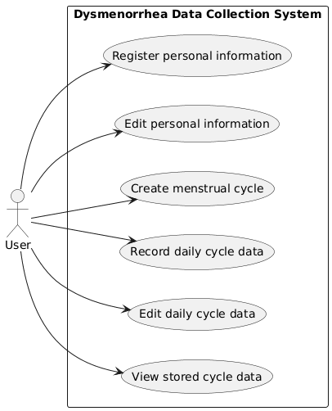

- Traceability Matrix
Requirement ID | Description | UC1 Register Personal Information | UC2 Edit Personal Information | UC3 Create Menstrual Cycle | UC4 Record Daily Cycle Data | UC5 Edit Daily Cycle Data | UC6 View Stored Data
FR1 | Store personal information for each user | X | X |  |  |  | X
FR2 | Store gynecological background data for each user | X | X |  |  |  | X
FR3 | Allow each user to register multiple menstrual cycles |  |  | X |  |  | X
FR4 | Allow each cycle to contain multiple daily entries |  |  | X | X | X | X
FR5 | Store daily dysmenorrhea-related symptoms |  |  |  | X | X | X
FR6 | Store daily lifestyle-related variables |  |  |  | X | X | X
FR7 | Allow previously stored data to be updated |  | X |  |  | X
FR8 | Retrieve stored user and cycle data |  |  |  |  |  | X
FR9 | Maintain relationships between users, cycles, and daily entries | X | X | X | X | X | X
NFR1 | Ensure data integrity through primary and foreign keys | X | X | X | X | X | X
NFR2 | Support scalability for storing data from multiple users | X | X | X | X | X | X
NFR3 | Provide a structured format suitable for future analysis | X | X | X | X | X | X

- ER Diagram
To transform this structure into a relational database, the information was normalized into three entities: USER, CYCLE, and CYCLE_DAY. A user can have multiple cycles, and each cycle can include multiple daily entries. This design preserves the application logic while improving scalability, consistency, and suitability for future data analysis and AI applications.
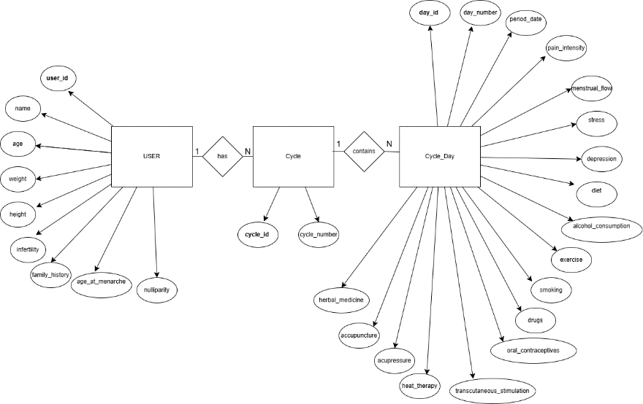
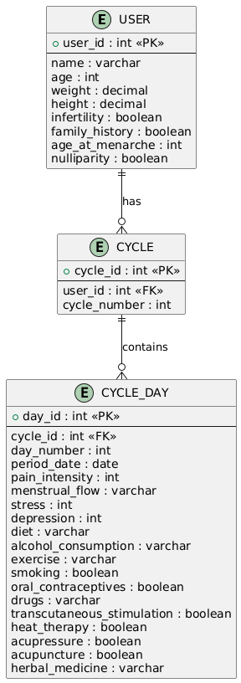
- Relational Model
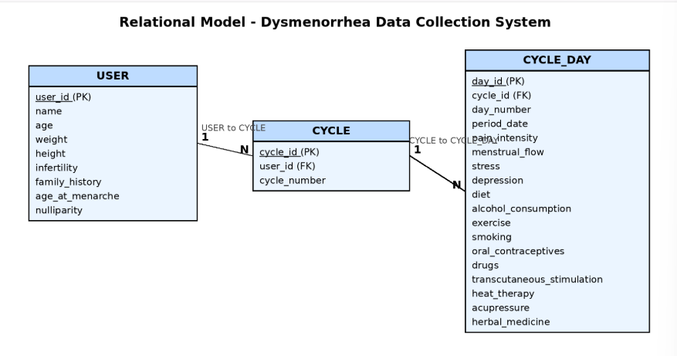
- SQL DDL

CREATE TABLE USER (
user_id INTEGER PRIMARY KEY AUTOINCREMENT,
name VARCHAR(100),
age INTEGER,
weight DECIMAL(5,2),
height DECIMAL(5,2),
infertility BOOLEAN,
family_history BOOLEAN,
age_at_menarche INTEGER,
nulliparity BOOLEAN
);

CREATE TABLE CYCLE (
cycle_id INTEGER PRIMARY KEY AUTOINCREMENT,
user_id INTEGER NOT NULL,
cycle_number INTEGER,
FOREIGN KEY (user_id) REFERENCES USER(user_id)
);

CREATE TABLE CYCLE_DAY (
day_id INTEGER PRIMARY KEY AUTOINCREMENT,
cycle_id INTEGER NOT NULL,
day_number INTEGER,
period_date DATE,
pain_intensity INTEGER,
menstrual_flow VARCHAR(20),
stress INTEGER,
depression INTEGER,
diet VARCHAR(100),
alcohol_consumption VARCHAR(50),
exercise VARCHAR(50),
smoking BOOLEAN,
oral_contraceptives BOOLEAN,
drugs VARCHAR(100),
transcutaneous_stimulation BOOLEAN,
heat_therapy BOOLEAN,
acupressure BOOLEAN,
acupuncture BOOLEAN,
herbal_medicine VARCHAR(100),
FOREIGN KEY (cycle_id) REFERENCES CYCLE(cycle_id)
);

- DML
To validate the database design, sample records were inserted into the USERS, CYCLE, and CYCLE_DAY tables. Several SQL queries were executed to verify that the data was stored correctly and that the relationships between tables worked as expected.
INSERT INTO USER (
user_id, name, age, weight, height, infertility, family_history, age_at_menarche, nulliparity
) VALUES (
1, 'Ana Lopez', 21, 58.5, 165.0, 0, 1, 12, 1
);

INSERT INTO CYCLE (
cycle_id, user_id, cycle_number
) VALUES (
1, 1, 1
);

INSERT INTO CYCLE_DAY (
day_id, cycle_id, day_number, period_date, pain_intensity, menstrual_flow,
stress, depression, diet, alcohol_consumption, exercise, smoking,
oral_contraceptives, drugs, transcutaneous_stimulation, heat_therapy,
acupressure, herbal_medicine
) VALUES (
1, 1, 1, '2026-04-01', 8, 'Heavy',
7, 4, 'Balanced', 'No', 'Light', 'No',
0, 'Ibuprofen', 0, 1,
0, 'Chamomile'
);

INSERT INTO CYCLE_DAY (
day_id, cycle_id, day_number, period_date, pain_intensity, menstrual_flow,
stress, depression, diet, alcohol_consumption, exercise, smoking,
oral_contraceptives, drugs, transcutaneous_stimulation, heat_therapy,
acupressure, herbal_medicine
) VALUES (
2, 1, 2, '2026-04-02', 6, 'Medium',
5, 3, 'Balanced', 'No', 'Moderate', 'No',
0, 'Ibuprofen', 1, 1,
1, 'Chamomile'
);
INSERT INTO USER VALUES (2, 'Marianna Benavides', 24, 60.0, 167.0, 0, 1, 13, 0);

INSERT INTO USER VALUES (3, 'Daniela Romoleroux', 22, 57.0, 162.0, 0, 0, 12, 1);

INSERT INTO USER VALUES (4, 'Carolina Santos', 26, 65.0, 170.0, 1, 1, 14, 0);

INSERT INTO CYCLE VALUES (2, 2, 1); -- Marianna
INSERT INTO CYCLE VALUES (3, 3, 1); -- Daniela
INSERT INTO CYCLE VALUES (4, 4, 1); -- Carolina

-- Cycle_Day for Marianna
INSERT INTO CYCLE_DAY VALUES
(3, 2, 1, '2026-04-05', 7, 'Heavy', 6, 4, 'Balanced', 'No', 'Light', 'No', 0, 'Ibuprofen', 0, 1, 0, 'Chamomile');

INSERT INTO CYCLE_DAY VALUES
(4, 2, 2, '2026-04-06', 5, 'Medium', 4, 3, 'Healthy', 'Yes', 'None', 'No', 0, 'None', 1, 1, 0, 'None');

-- Cycle_Day for Daniela
INSERT INTO CYCLE_DAY VALUES
(5, 3, 1, '2026-04-10', 9, 'Heavy', 8, 6, 'Poor', 'Yes', 'None', 'Yes', 1, 'Paracetamol', 0, 1, 1, 'Mint');

INSERT INTO CYCLE_DAY VALUES
(6, 3, 2, '2026-04-11', 7, 'Medium', 6, 5, 'Balanced', 'No', 'Moderate', 'No', 1, 'Paracetamol', 1, 1, 0, 'Chamomile');

-- Cycle_Day for Carolina
INSERT INTO CYCLE_DAY VALUES
(7, 4, 1, '2026-04-15', 6, 'Light', 5, 2, 'Balanced', 'No', 'Moderate', 'No', 0, 'None', 0, 1, 1, 'None');

INSERT INTO CYCLE_DAY VALUES
(8, 4, 2, '2026-04-16', 4, 'Light', 3, 2, 'Healthy', 'No', 'Moderate', 'No', 0, 'None', 0, 0, 0, 'None');

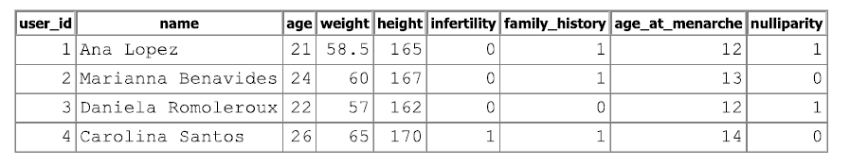
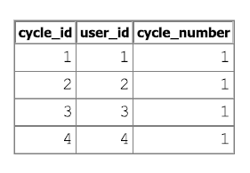
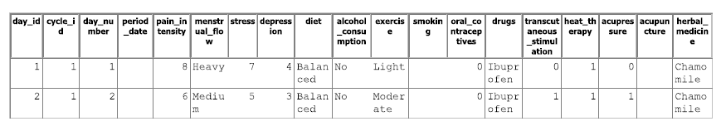

INSERT INTO CYCLE_DAY (
day_id, cycle_id, day_number, period_date, pain_intensity, menstrual_flow,
stress, depression, diet, alcohol_consumption, exercise, smoking,
oral_contraceptives, drugs, transcutaneous_stimulation, heat_therapy,
acupressure, herbal_medicine
) VALUES (
3, 2, 1, '2026-04-05', 7, 'Heavy',
6, 4, 'Balanced', 'No', 'Light', 'No',
0, 'Ibuprofen', 0, 1,
0, 'Chamomile'
);

INSERT INTO CYCLE_DAY (
day_id, cycle_id, day_number, period_date, pain_intensity, menstrual_flow,
stress, depression, diet, alcohol_consumption, exercise, smoking,
oral_contraceptives, drugs, transcutaneous_stimulation, heat_therapy,
acupressure, herbal_medicine
) VALUES (
4, 2, 2, '2026-04-06', 5, 'Medium',
4, 3, 'Healthy', 'Yes', 'None', 'No',
0, 'None', 1, 1,
0, 'None'
);

INSERT INTO CYCLE_DAY (
day_id, cycle_id, day_number, period_date, pain_intensity, menstrual_flow,
stress, depression, diet, alcohol_consumption, exercise, smoking,
oral_contraceptives, drugs, transcutaneous_stimulation, heat_therapy,
acupressure, herbal_medicine
) VALUES (
5, 3, 1, '2026-04-10', 9, 'Heavy',
8, 6, 'Poor', 'Yes', 'None', 'Yes',
1, 'Paracetamol', 0, 1,
1, 'Mint'
);

INSERT INTO CYCLE_DAY (
day_id, cycle_id, day_number, period_date, pain_intensity, menstrual_flow,
stress, depression, diet, alcohol_consumption, exercise, smoking,
oral_contraceptives, drugs, transcutaneous_stimulation, heat_therapy,
acupressure, herbal_medicine
) VALUES (
6, 3, 2, '2026-04-11', 7, 'Medium',
6, 5, 'Balanced', 'No', 'Moderate', 'No',
1, 'Paracetamol', 1, 1,
0, 'Chamomile'
);

INSERT INTO CYCLE_DAY (
day_id, cycle_id, day_number, period_date, pain_intensity, menstrual_flow,
stress, depression, diet, alcohol_consumption, exercise, smoking,
oral_contraceptives, drugs, transcutaneous_stimulation, heat_therapy,
acupressure, herbal_medicine
) VALUES (
7, 4, 1, '2026-04-15', 6, 'Light',
5, 2, 'Balanced', 'No', 'Moderate', 'No',
0, 'None', 0, 1,
1, 'None'
);

INSERT INTO CYCLE_DAY (
day_id, cycle_id, day_number, period_date, pain_intensity, menstrual_flow,
stress, depression, diet, alcohol_consumption, exercise, smoking,
oral_contraceptives, drugs, transcutaneous_stimulation, heat_therapy,
acupressure, herbal_medicine
) VALUES (
8, 4, 2, '2026-04-16', 4, 'Light',
3, 2, 'Healthy', 'No', 'Moderate', 'No',
0, 'None', 0, 0,
0, 'None'
);
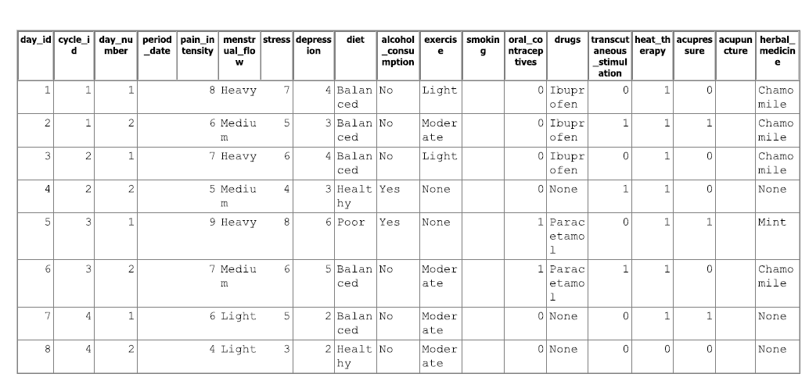
SELECT QUERIES: used to test if the database is well created.
Visualize all the users:
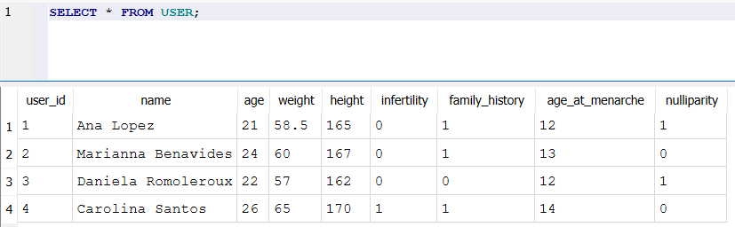
Visualize all the cycles:
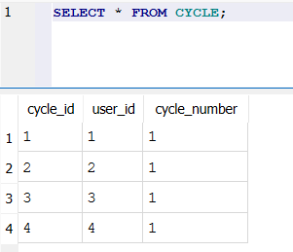
Visualize all the days of the cycles:
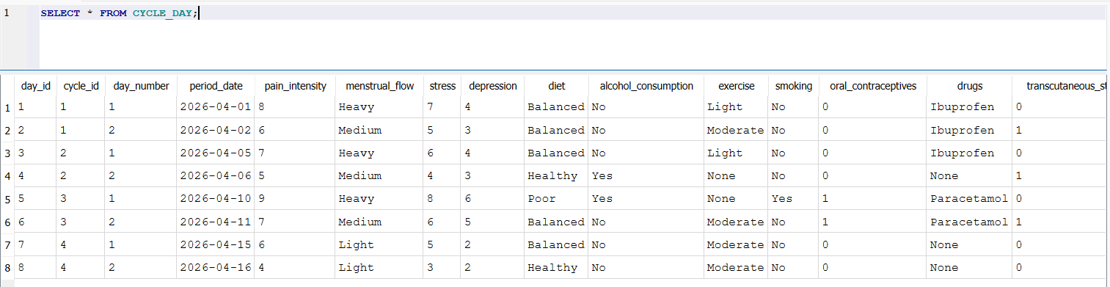
- SELECT with filters
Visualize the days with high pain:
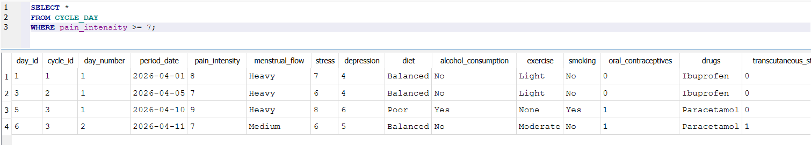
Visualize the days only with a heavy menstrual flow
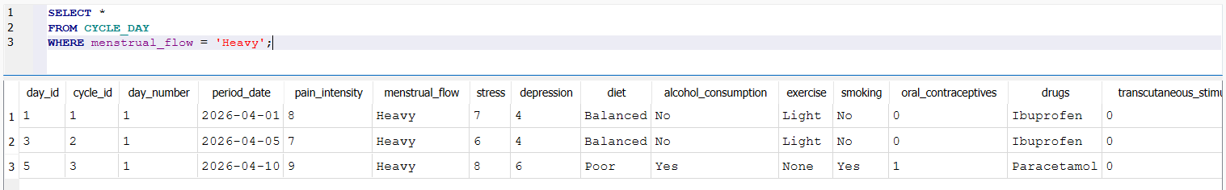
Visualize the days in which they consumed more alcohol
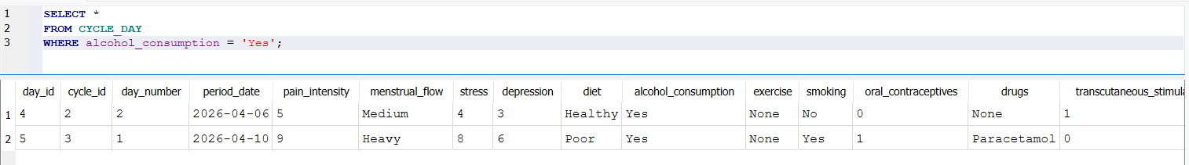
- SELECT with JOIN
Visualize the complete information per user
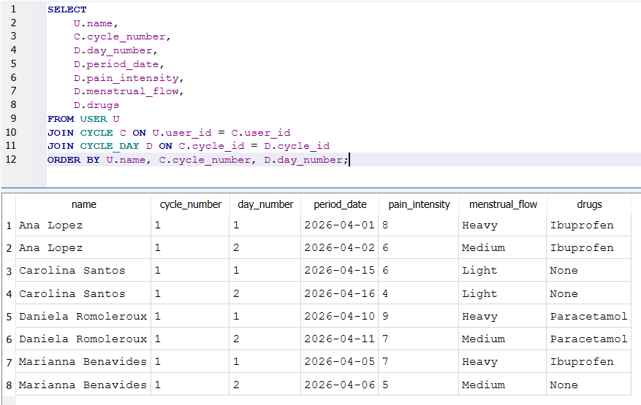
Visualize an only one user
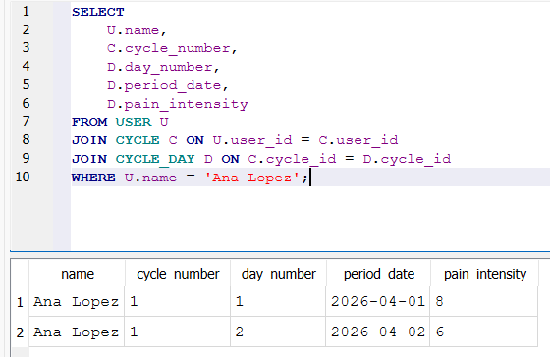
Average pain per user
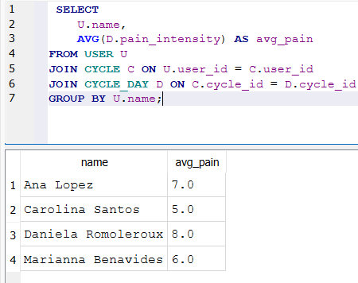
Maximum pain registered per user
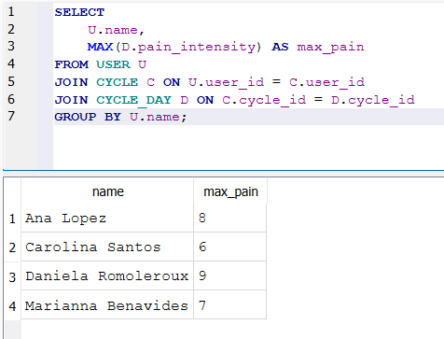
Number of days registered per cycle
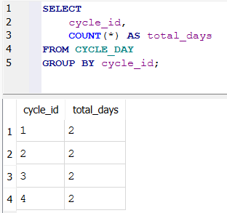
- UPDATE queries
Change the weight of a user
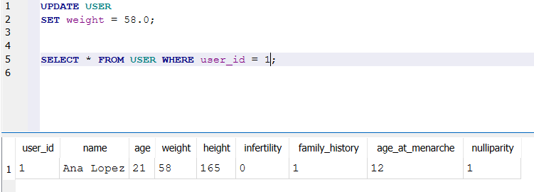
Change the pain intensity of a day
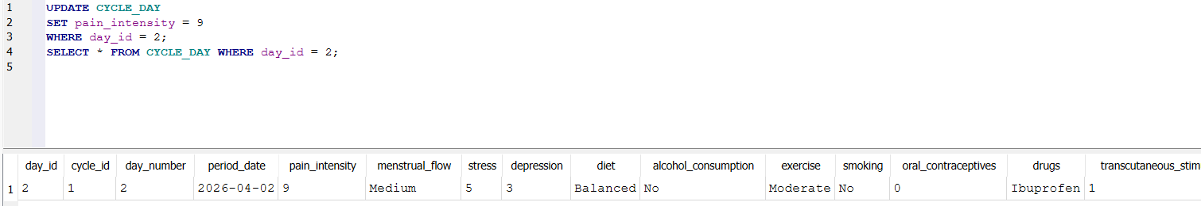
Change the treatment used
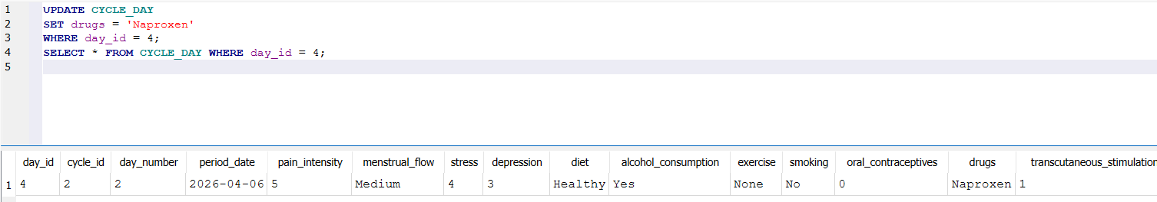
- Visualize users with pain medium-high
